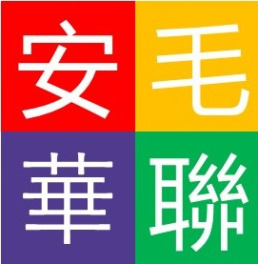 | Mauritius-Chinese Association of Ontario  安大略省模里西斯華人聯誼會
https://mauritiuschineseassociation.com/
Membership Registration Form
Instructions:
- Once the form has been completed, please email it as an attachment to clubmcao@gmail.com for processing along with the membership payment.
- Membership fees are $45/single and $80/couple per calendar year.
- Membership fees are to be sent to the Treasurer/Assistant-Treasurer by cash or cheque made payable to Mauritius-Chinese Association of Ontario.
- Applicant will be informed by email or phone when registration process has been completed.
Membership Information

Full Last/First Name (Mr.): _____________________________________________________
Full Last/First Name (Mrs.): _____________________________________________________
Address: _________________________________ City: _____________________________
Province: _________________________________ Postal Code: ______________________
Tel (Mr.): _______________________ Tel (Mrs.): ________________________
Email Address (Mr.): _______________________ Year of Birth: ____________________
Email Address (Mrs.): ______________________ Year of Birth¹: ____________________
Emergency Contact Name: __________________ Emergency Contact #: ______________
As a new member, we value your opinion. Kindly indicate the following:

- Your area of expertise e.g. Administrative, IT, Accounting, other _________________
- Interested to be part of the Executive Board of Directors? Maybe/Yes/No
- Interested in volunteering/providing assistance for the club? Maybe/Yes/No
- Interested activities (Please circle):
Line Dance, Yoga, Karaoke, Cardio, Arts, Outdoor activities, social gathering, group bus trip, other_________________________________________________________
- Other suggested activities?
- Print or Sign Name(s) ___________________________ Date _________________
I/We, Applicant/s hereby confirm that the printed name(s) is/are considered digitally signed.

Required for senior programming

